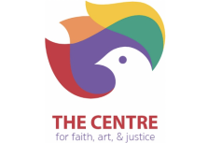**The Centre for Faith, Art & Justice: Mission**

The Centre for Faith, Art, & Justice (CFAJ) is the community service arm of The First Baptist Church in Jamaica Plain whose mission is to foster the integration of the arts, faith, culture, education, and social justice.

Founded in 2019, The CFAJ was established as the 501c3 nonprofit arm of the First Baptist Church in Jamaica Plain (FBCJP) to serve as a community destination for marginalized residents from the greater Boston area. The Centre's host organization, FBCJP, has been actively supporting the Boston community for over 182 years.

**Food Justice**

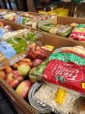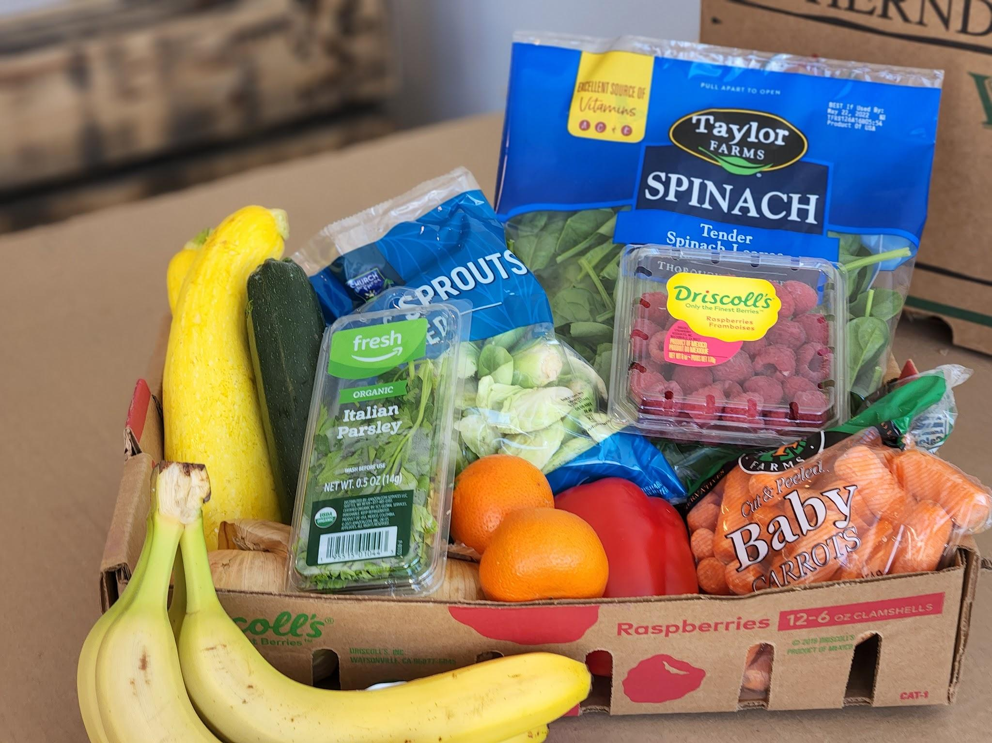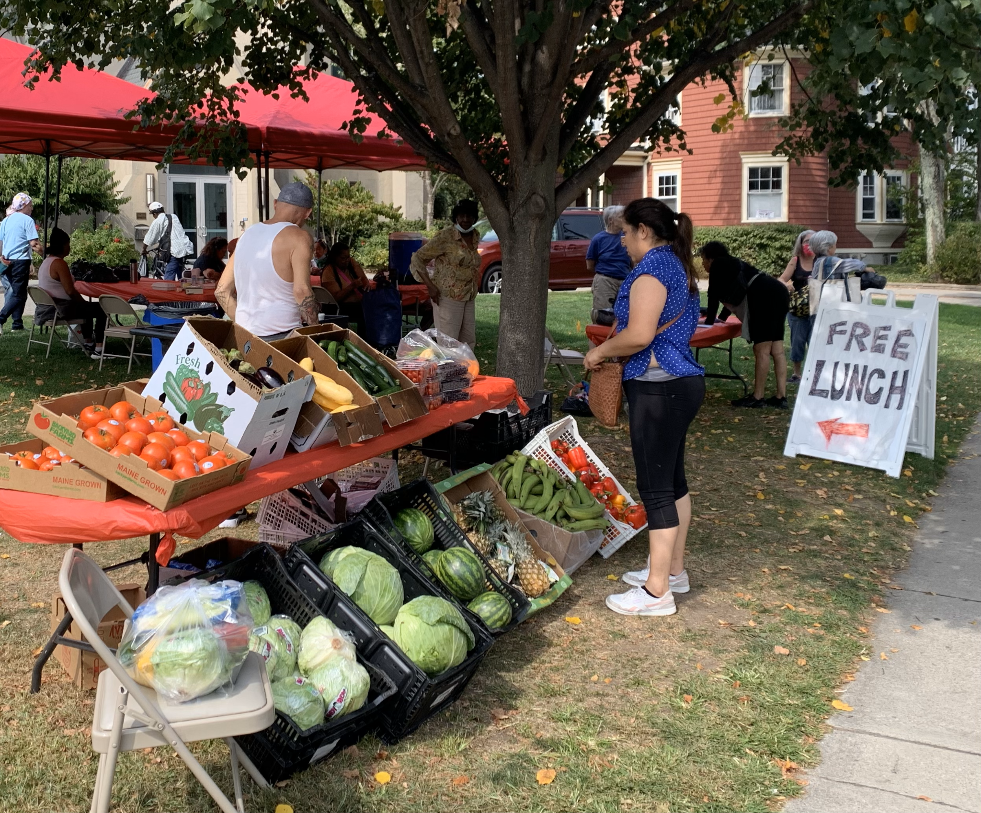

The Food Justice Program distributes 75,000+ lbs of food/month providing greater Boston neighbors access to healthy food through:

*Community lunches which are prepared fresh in our kitchen 4 times a week and are available free of charge for all community members. On average we distribute over 600 meals a week.

*Community pantry which is open 5 days a week, where families may pick up a box of groceries and bag of fresh produce at their convenience, on a weekly basis. The pantry is open Tuesday through Saturday, and currently serves over 400 families.

*The Centre Food Hub is a low-cost community market which offers high-quality produce, bread and dairy products. The Food Hub is open Tuesday through Saturday, and everyone is welcome.

*The Community Kitchen is a Professional Grade Commissary Kitchen with rental opportunities for start-up catering and culinary entrepreneurs, as well as community based organizations.

The Centre’s Food Justice Program remains one of the fastest growing food security initiatives serving Greater Boston. Our mission is to help to mitigate the growing hunger crisis of neighbors impacted by food insecurity and unhealthy diets. These individuals and families are at highest risk for poor health and chronic disease.

Program priorities include:

* Improving the health outcomes of others by increasing access to recovered, donated and wholesale fresh food and produce.
* Mobilizing partnerships with the Mayor’s Office of Food Justice (OFJ) and strategic like-partner programs who together seek to build a citywide food system that is equitable, resilient, sustainable and just.
* Dispelling myths about food insecurity through increased outreach with a focus on recipient dignity, as we continue to provide an all access model of community: hot meals, 5-day pantry pickups and a 5-day Centre Food Hub store
* Sharing our commissary kitchen with entrepreneurial caterers in need of a base of operations.
* Building community engagement through increased volunteerism and ongoing food justice education to stakeholders.

**Next Steps with Food Justice Collaboration** 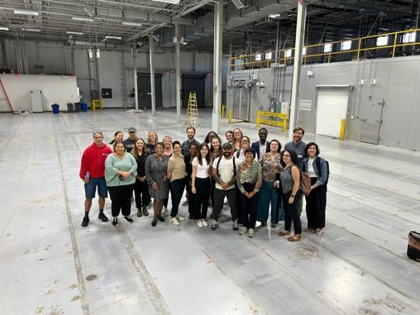

Boston’s largest multi-service non-profit organizations (the YMCA of Greater Boston and ABCD) along with three other Community Based Organizations with extensive experience working in the city of Boston (NFAC, the FBCJP’s Centre for Faith, Art & Justice, and Fresh Truck) have joined efforts to plan, share, decide and grow a deeply collaborative refrigerated warehouse project. This project is designed to serve, support and empower food insecure residents of Boston.

**Outcomes from a Collaborative Food Access Hub:** The collaborative storage facility and the opportunity to increase the scale of rescued food available for Boston residents will systematically address the lack of availability of fresh fruits and vegetables faced by vulnerable Boston residents.Specific, measurable outcomes from a successful collaboration with all partners will include:

* Creating a food access hub for aggregating rescued food, donated food and food purchased from MA farmers at fair prices, which will allow fresh surplus food to be collected (daily) and stored for up to a maximum of 24 hours for distribution to partner sites.
* Providing cold-chain and temperature control, quality and appropriateness of food and will minimize the distance between surplus food pick up and recipient site locations, to ensure food safety standards are met throughout the storage and distribution chain. Working with partners to recover larger loads of a wider range of products, including fresh, cooked, and dry food, fruits and vegetables. Making it easier to donate more varied, nutritious, and balanced food for community recipients .
* Identifying opportunities to provide distribution infrastructure and fair prices to small, local sustainable food distribution programs.

**CENTRE FOR FAITH ART & JUSTICE**

**Food Justice Program**

633 Centre St

JAMAICA PLAIN, Massachusetts 02130-2526

Phone 617-971-8840

<https://www.thecentrejp.org/food-justice>